NAME: Manaswi Raj Branch / Sec: CSE / CSE -5 Batch: Lab 1

QUANTUM GATES USING SIMULATION
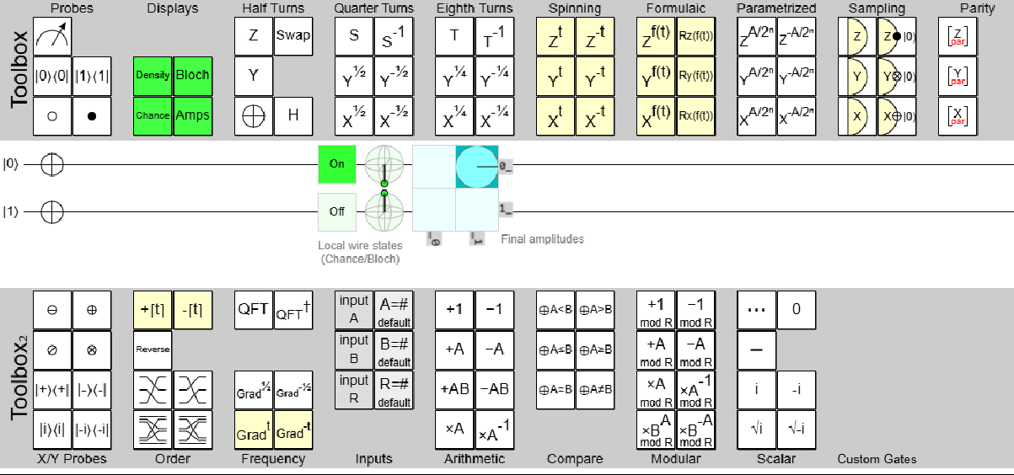
Pauli’s X – Gate:

Truth Table:

INPUT | OUTPUT
|0> | |1>
|1> | |0>
α |0> +β |1> | α |1> +β |0>

Pauli’s Y – Gate:
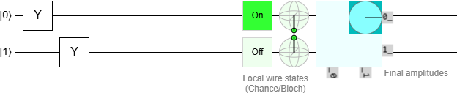

Truth Table:

INPUT | OUTPUT
|0> | i|1>
|1> | -i|0>
α |0> +β |1> | α i |1> - i β |0>

Pauli’s Z – Gate:
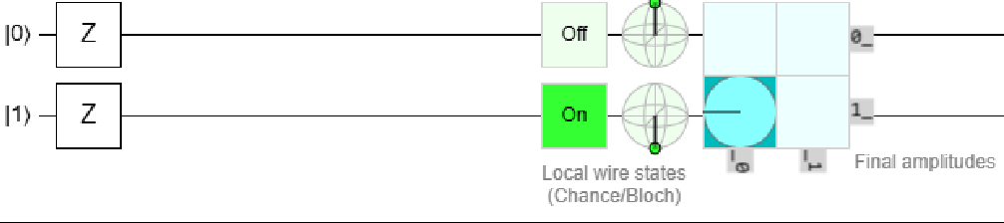
Truth Table:

INPUT | OUTPUT
|0> | |0>
|1> | -|1>
α |0> +β |1> | α |0> - β |1>

Pauli’s S – Gate:
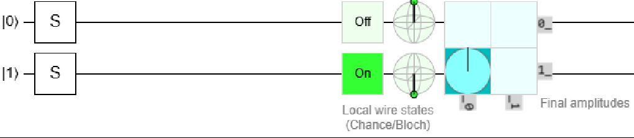
Truth Table:

INPUT | OUTPUT
|0> | |0>
|1> | i|1>
α |0> +β |1> | α |0> i β |1>

Controlled gate/CNOT gate
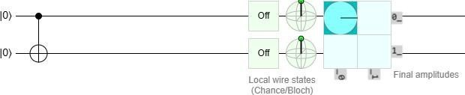
Truth Table:

INPUT | OUTPUT
|00> | |00>
|01> | |01>
|10> | |11>

|11> | |10>

Swap Gate:

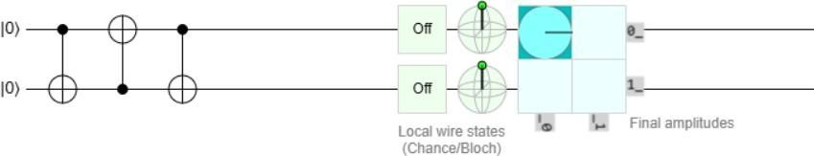
Truth Table:

INPUT | OUTPUT
|00> | |00>
|01> | |10>
|10> | |01>
|11> | |11>
Controlled-Z gate:
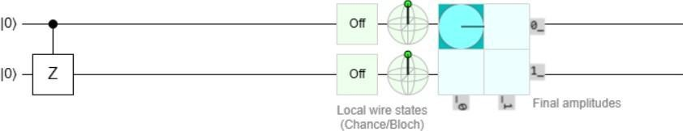

INPUT | OUTPUT
|00> | |00>
|01> | |01>
|10> | |10>
|11> | -|11>
Toffoli gate (CCNOT, CCX, TOFF):
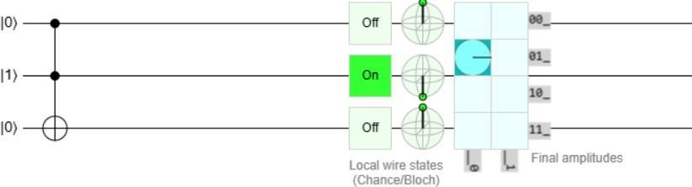

|a> | |b> | |c> | |a’> | |b’> | |c’>
0 | 0 | 0 | 0 | 0 | 0
0 | 0 | 1 | 0 | 0 | 1
0 | 1 | 0 | 0 | 1 | 0
0 | 1 | 1 | 0 | 1 | 1
1 | 0 | 0 | 1 | 0 | 0
1 | 0 | 1 | 1 | 0 | 1
1 | 1 | 0 | 1 | 1 | 1
1 | 1 | 1 | 1 | 1 | 0

